Purpose
To define a system for estimation and expression of measurement uncertainty in all the testing.

Scope
This procedure applies to SMJ Lab, for estimation and expression of uncertainty in measurement in testing.

Normative References

ISO/IEC 17025:2017
General requirements for the competence of testing and calibration laboratories.

ISO/IEC Guide 98-3:2008:
Guide to the expression of uncertainty in measurement (GUM:1995)

NABL 141:
Guidelines for Estimation and Expression of Uncertainty in Measurement

A2LA G104:
Guide for Estimation of Measurement Uncertainty in Testing (September 2019)

SMJ/QSP/05:
Procedure for Intermediate Checks

SMJ/QSP/12:
Procedure for ensuring the validity of results

SMJ/QSP/14:
Procedure for Control of non-conforming work

Definitions

Measurement Uncertainty
A non-negative parameter, associated with the result of a measurement that characterizes the dispersion of the values that could reasonably be attributed to the measurand (a particular quantity or concentration of a species subject to measurement).

Standard Uncertainty
Uncertainty of the result of a measurement expressed as a standard deviation.

Type A evaluation (of uncertainty)
Method of evaluation of uncertainty by the statistical analysis of series of observations.

Type B evaluation (of uncertainty)
Method of evaluation of uncertainty by means other than the statistical analysis of series of observations.

Combined Standard Uncertainty
Standard uncertainty of the result of a measurement when that result is obtained from the values of a number of other quantities, equal to the positive square root of a sum of terms, the terms being the variances or covariances of these other quantities weighted according to how the measurement result varies with changes in these quantities.

Coverage Factor
Numerical factor used as a multiplier of the combined standard uncertainty in order to obtain an expanded uncertainty.

Expanded Uncertainty
Quantity defining an interval about the result of a measurement that may be expected to encompass a large fraction of the distribution of values that could reasonably be attributed to the measurand.

Responsibilities

Quality Manager:
The Quality Manager holds overall responsibility for ensuring the implementation of this procedure and provides training and guidance to personnel involved in uncertainty estimation and expression.

Laboratory Staff:
Laboratory Staff are responsible for identifying sources of uncertainty associated with measurement processes, collecting and analyzing the data necessary for uncertainty estimation, and implementing corrective actions to minimize uncertainty wherever possible.

Procedure

Specify Measurand:
In the context of uncertainty estimation, “specification of the measurand” requires a clear and unambiguous statement of:
- What is being measured (e.g. moisture, ash, etc.)
- Quantitative expression relating the value of the measurand to the parameters on which it depends (e.g. Formula). Precise information is to be given for all parameters in the Quantitative expression with units.
- Method used for the measurement.

Identify Uncertainty Sources:
There are many possible sources of uncertainty of measurement in testing, including but not limiting to Sampling, Storage Conditions, Instrument effects, Reagent purity, Assumed stoichiometry, Measurement conditions, Sample effects, Blank Correction, Operator effects, Random effects, etc. (Note: These sources are not necessarily independent).
The laboratory makes a reasonable estimation based on above sources to ensure that the reporting of results accurately reflects the level of uncertainty. This assessment considers factors such as method performance, measurement scope and application, past experiences, and validation data as needed. To achieve this, the laboratory utilizes a "Fish Bone" diagram to identify key factors influencing result accuracy (Refer Annexure 1 of this document for a detailed list of factors and criteria for evaluation, while identifying/identified sources of uncertainty).

Evaluation of Uncertainty:
The ISO Guide 98 categorizes uncertainty components into two distinct groups based on their method of assessment: Type A and Type B evaluation methods, this categorization is based on the method of evaluation rather than on the components themselves.

Type A Evaluation of Standard Uncertainty:
Uncertainty evaluated using statistical methods is referred to as Type A, these uncertainties are based upon repeated measurements from a controlled process and are described by the familiar Normal (or “Standard”) probability distribution that yields an average and standard deviation for the set.
Standard Uncertainty:
$$U_{a}=\frac{s}{\sqrt{n}}$$ | Where: $U_{a}$ → Type A Standard Uncertainty  $s$ → Experimental Standard Deviation  n → number of values  Degrees of freedom ($v_{a}$) = (n -1)

Type B Evaluation of Standard Uncertainty
All other ways of evaluating uncertainty are referred to as Type B. Type B uncertainties are always expressed as probability distributions. The equations used to calculate the standard uncertainty for three common probability distribution models i.e. normal, rectangular or uniform, and triangular.

Combining Uncertainty Components
Although uncertainty components are not errors, the individual components are combined using law of propagation of error formulas in which the combined uncertainty, U_C is the square root of the sum of the squares (RSS) of the individual uncertainty components, each scaled to reflect its potential impact on the final result.
$$U_{C}=\sqrt{\left({u_{1}}^{2}+{u_{2}}^{2}+{u_{3}}^{2}+…+{u_{n}}^{2}\right)}$$
Where: u₁, u₂ ,….. ,u_{n} = Standard Uncertainties of Individual Contribution, up to the last number.

Determining the Coverage Factor (k)
The coverage factor ‘k’ is obtained from the table of values of student “t” distribution for the result of $v_{eff}$at 95 % confidence level. Generally, $v_{eff}$is obtained as ∞ and coverage factor for same at 95 % confidence level is 2 if the value of $v_{eff}$is not an integer, it is truncated to the next lower integer and the corresponding coverage factor ‘k’ is obtained from the table below:
Confidence Level and the corresponding Coverage factor (k)
Confidence level | 68.27 % | 90.00 % | 95.00 % | 95.45 % | 99.00 % | 99.73 %
Coverage factor (k) | 1.000 | 1.645 | 1.960 | 2.000 | 2.576 | 3.000

Normal Distribution:
Form | Use when: | Uncertainty
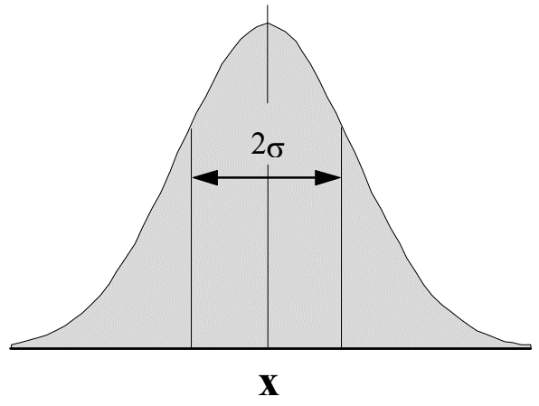 | - An estimate is made from repeated observations of a randomly varying process. | u(x) = s
 | - An uncertainty is given in the form of a standard deviation s, a relative standard deviation s/x̅, or a percentage coefficient of variance %CV without specifying the distribution. | u(x) = s  u(x)=x⋅(s/x̅)  u(x)= %CV⋅ x/100
 | - An uncertainty is given in the form of a 95 % (or other) confidence interval x±c without specifying the distribution. | u(x) = c/2 (for c at 95 %)  u(x) = c/3 (for c at 99.7 %)
Rectangular Distribution:
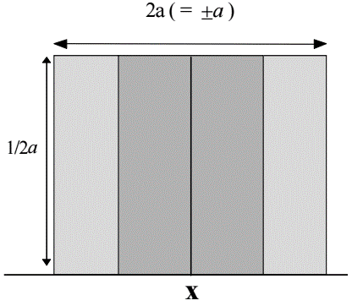 | - A certificate or other specification gives limits without specifying a level of confidence (e.g. 25 mL ± 0.05 mL)  - An estimate is made in the form of a maximum range (±a) with no knowledge of the shape of the distribution. | u(x)=a/√3
Triangular Distribution:
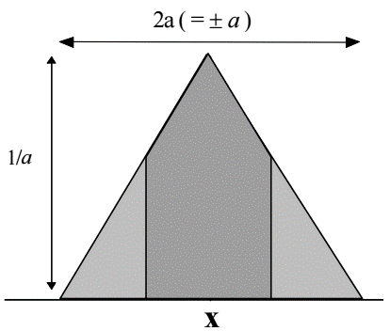 | - The available information concerning x is less limited than for a rectangular distribution. Values close to x are more likely than near the bounds.  - An estimate is made in the form of a maximum range (±a) described by a symmetric distribution. | u(x)=a/√6

Expanded Uncertainty:
After the magnitudes of the significant components of uncertainty are calculated they are combined and multiplied by a coverage factor, k, to determine the expanded uncertainty.
$$U_{Expanded}=k×U_{C}$$
Final results are reported as: $Result±U_{Expanded}$

Eliminating Sensitivity Coefficient:
Sensitivity Coefficient is eliminated by the laboratory wherever not possible/applicable and considering that it is always ‘1’ & ‘k’ is taken as 2.

Uncertainty Budget:
A table listing the sources and values of uncertainty components is an uncertainty budget. It is a useful tool but there is no mandated format and many forms are used. It is quite possible to evaluate and combine uncertainty contributions without using a budget. Along with the budget table or other listing of the constituent uncertainties, it is important that a well-documented narrative be available for every uncertainty analysis. An independent, detailed exposition is not needed every time an analysis is undertaken, however. If the conditions and assumptions used to estimate an uncertainty are the same in one case as they were in a past case, then the narrative developed for a past case is applicable to the present case and need not be duplicated. However, it may be necessary to update the values of specific uncertainty contributors if new information becomes available.

Records:
- Records of uncertainty estimation shall be maintained for each measurement process, including documentation of identified sources of uncertainty, estimation methods used, and calculated uncertainties.
- Records shall be retained in accordance with SMJ Lab's document control procedures and shall be made available for review during internal audits and external assessments.

Important Notes

Uncertainty in Measurement Results:
A statement of results of measurement (as a process) is complete only if it contains both the values attributed to the measure and the uncertainty in measurement associated with that value. Without such an indication, measured results cannot be compared, either among themselves or with reference values given in a specification or standard.

Nature of Errors and Uncertainty:
Errors in the observed results of a measurement (process) give rise to uncertainty about the true value of the measured results as is obtained (estimated) from those results. Both systematic and random errors affecting the observed results (measurements) contribute to this uncertainty. These contributions have been sometimes referred to as systematic and random components of uncertainty respectively.

Standard Uncertainty in Measurement:
The standard uncertainty of measurement associated with the output estimate y, denoted by U(y), is the standard deviation of the unknown (true) values of the measure Y corresponding to the output estimate.

Type B Evaluation of Uncertainty:
The Type B evaluation commonly considered from the value of uncertainty from external calibration certificate and made into ½ (K = 2 as quoted on certificate at 95% probabilities). More details of type B uncertainty calculation. (Refer Annexure 2).

Expanded Uncertainty in Measurement:
Hence Reported expanded uncertainty in measurement is the standard combined uncertainty in measurement multiplied by the coverage factor k = 2, which for a normal distribution corresponds to a coverage probability of approximately 95%.

ANNEXURE 1
Factors and Criteria Evaluated for Identifying /Identified Sources of Uncertainty in Measurements
- Uncertainties in Analytical Processes:
- Sampling
- Homogeneity.
- Effects of specific sampling strategy (e.g. random, stratified random, proportional etc.)
- Effects of movement of bulk medium (particularly density selection)
- Physical state of bulk (solid, liquid, gas)
- Temperature and pressure effects.
- Does sampling process affect composition? e.g. differential adsorption in sampling system.
- Sample preparation
- Homogenisation and/or sub-sampling effects.
- Drying.
- Milling.
- Dissolution.
- Extraction.
- Contamination.
- Derivatisation (chemical effects)
- Dilution errors.
- (Pre-) Concentration.
- Control of speciation effects.
- Presentation of Certified Reference Materials to the measuring system
- Uncertainty for CRM.
- CRM match to sample
- Calibration of instrument
- Instrument calibration errors using a Certified Reference Material.
- Reference material and its uncertainty.
- Sample match to calibrant
- Instrument precision
- Analysis
- Carry-over in auto analysers.
- Operator effects, e.g. colour blindness, parallax, other systematic errors.
- Interferences from the matrix, reagents or other analytes.
- Reagent purity.
- Instrument parameter settings, e.g. integration parameters
- Run-to-run precision
- Data Processing
- Averaging.
- Control of rounding and truncating.
- Statistics.
- Processing algorithms (model fitting, e.g. linear least squares).
- Presentation of Results
- Final result.
- Estimate of uncertainty.
- Confidence level.
- Interpretation of Results
- Against limits/bounds.
- Regulatory compliance.
- Fitness for purpose.
- Common Sources and Values of Uncertainty
The following tables summarise some typical examples of uncertainty components. The tables give:
- The particular measurand or experimental procedure (determining mass, volume etc.)
- The main components and sources of uncertainty in each case
- A suggested method of determining the uncertainty arising from each source.
- An example of a typical case
The tables are intended only to indicate methods of estimating the value of some typical measurement uncertainty components in analytical measurement. They are not intended to be comprehensive, nor should the values given be used directly without independent justification. The values may, however, help in deciding whether a particular component is significant.
Determination | Uncertainty Components | Cause | Method of determination | Typical values
 |  |  |  | Example | Value
Mass | Balance calibration  uncertainty | Limited accuracy in  calibration | Stated on calibration certificate, converted to standard deviation | 4-figure balance | 0.5 mg
 | Linearity |  | - Experiment, with range of certified weights  - Manufacturer's specification |  | ca. 0.5x last  significant  digit
 | Readability | Limited resolution on  display or scale | From last significant digit |  | 0.5x last  significant  digit/√3
 | Daily drift | Various, including  temperature | Standard deviation of long term  check weighings. Calculate as RSD if necessary |  | ca. 0.5x last  significant  digit.
 | Run to run variation | Various | Standard deviation of successive sample or check weighings |  | ca. 0.5x last  significant  digit.
 | Density effects  (conventional basis) | Calibration weight/sample density mismatch causes a difference in the effect of atmospheric buoyancy | Calculated from known or assumed densities and typical atmospheric conditions | Steel, Nickel  Aluminium  Organic solids  Water  Hydrocarbons | 1 ppm  20 ppm  50-100 ppm  65 ppm  90 ppm
 | Density effects  (in vacuo basis) | As above | Calculate atmospheric buoyancy effect and subtract buoyancy effect on calibration weight. | 100 g water  10 g Nickel | +0.1g (effect)  <1 mg (effect)
Volume (liquid) | Calibration uncertainty | Limited accuracy in calibration | Stated on manufacturer's specification, converted to standard deviation.  For ASTM class A glassware of volume V, the limit is approximately V^{0.6}/200 | 10 mL (Grade  A) | 0.02 / √3 =  0.01 mL*
 | Temperature | Temperature variation from the calibration temperature causes a difference in the volume at the standard temperature. | ∆T⋅α/(2√3) gives the relative standard deviation, where ∆T is the possible temperature range and α the coefficient of volume expansion of the liquid. α is approximately 2×10-4 K-1 for water and 1×10-3 K-1 for organic liquids.  For plastic volumetric equipment the coefficient of expansion for the vessel may also need to be considered | 100 mL water | 0.03 mL for operating within 3°C of the stated operating temperature  α is typically  4 × 10-4 for  polypropylene
 | Run to run variation | Various | Standard deviation of successive  check deliveries (found by  weighing) | 25 mL pipette | Replicate  fill/weigh:  s = 0.0092 mL

Determination | Uncertainty Components | Cause | Method of determination | Typical values
Analyte  concentration from  a reference  material certificate | Purity | Impurities reduce the amount of reference material present. Reactive impurities may interfere with the measurement. | Stated on manufacturer’s certificate. Reference material certificates may give unqualified limits; these should accordingly be treated as rectangular distributions and divided by √3.  Note: where the nature of the impurities is not stated, additional allowance or checks may need to be made to establish limits for interference etc. | Reference  potassium  hydrogen  phthalate  certified as  99.9±0.1 % | 0.1/√3 =  0.06 %
 | Concentration  (certified) | Uncertainty in certified  concentration in reference  material. | Stated on manufacturer’s certificate. Reference material certificates may give unqualified limits; these should accordingly be treated as rectangular distributions and divided by √3. | Cadmium  acetate in 4 %  acetic acid.  Certified as  (1000±2) mg L | 2/√3 = 1.2  mg L-1  (0.0012 as  RSD)*
 | Concentration  (made up from certified pure material) | Combination of uncertainties in reference values and intermediate steps | Combine values for prior steps as RSD throughout. | Cadmium  acetate after  three dilutions  from 1000  mg L⁻¹ to  0.5 mg L⁻¹ | Sqrt(0.0012²+  0.0017²+  0.0021²+  0.0017²+)  = 0 0034  as RSD
Absorbance | Instrument calibration  Note: this component relates to absorbance reading versus reference absorbance, not to the calibration of concentration against absorbance reading | Limited accuracy in  calibration. | Stated on calibration certificate as limits, converted to standard deviation
 | Run to run variation | Various | Standard deviation of replicate determinations, or QA performance. | Mean of 7 absorbance readings with s=1.63 | 1.63/√7 = 0.62
Sampling | Homogeneity | Sub-sampling from inhomogeneous material will not generally represent the bulk exactly.  Note: random sampling  will generally result in  zero bias. It may be  necessary to check that  sampling is actually  random. | - Standard deviation of separate sub-sample results (if the inhomogeneity is large relative to analytical accuracy).  - Standard deviation estimated from known or assumed population parameters. | Sampling from  bread of  assumed two- valued  inhomogeneity | For 15 portions  from 72  contaminated  and 360  uncontaminated  bulk portions:  RSD = 0.58
Extraction  recovery | Mean recovery | Extraction is rarely  complete and may add or  include interferents. | Recovery calculated as percentage recovery from matched reference material or representative spiking. Uncertainty obtained from standard deviation of mean of recovery experiments.  Note: recovery may also be  calculated directly from  previously measured partition  coefficients. | Recovery of  pesticide from  bread; 42  experiments,  mean 90 %,  s=28 % | 28/√42= 4.3 %  (0.048 as  RSD)
 | Run to run variation in recovery | Various | Standard deviation of replicate experiments. | Recovery of pesticides from bread from paired replicate data | 0.31 as RSD.

